MOVEMENTS OF THE PIECES
Introduction:
Our first step in learning the chess moves, the beginner’s guide will help us understand the various patterns of the different pieces.
- King:
The King, being the most important piece, moves and captures one square in all directions. Its value is infinite.
He cannot be capture as other pieces and remains till the end of the game. If King is checkmated the game is over.

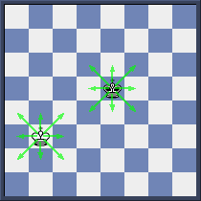
Note: King can neither move to the squares controlled by opponent pieces nor capture a protected opponent piece.

In the above position, Black is to move and the only move he can make is 1…Ka7 as b7 and b8 squares are controlled by White King.
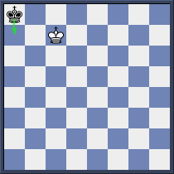
- Queen:

The Queen, being the most powerful piece, can go along a file, rank or diagonal. She cannot jump over other pieces.
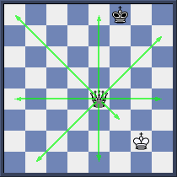

- Rook :

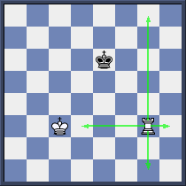
Rook, the second strongest piece, can move along a file and rank but cannot jump over other pieces.

- Bishop :

Bishop can move along a diagonal with its respective color. At the start of the game we have 2 Bishops: the White square Bishop (moving on white squares only) and the Black square Bishop (moving on black squares only). Bishop cannot jump over other pieces.

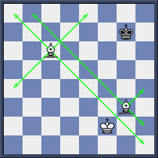

- Knight :
The Knight considered the most unique piece because of its movement, travels in a L-shape pattern; it also has the ability to jump over pieces and pawns.
Note that coming from a light square, it’s next jump square must be a dark square or vice versa.

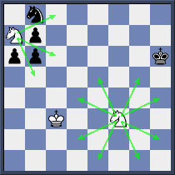
We see that White surrounded Knight at a7 still can move as usual. Besides, we also note that a centred Knight (Nf3) has more moves available than a cornered Knight (Na7).

- Pawns :
The pawn is called the foot soldier in a chess game and can advance one or two steps from its original square; afterwards one square only. The capture of the pawn is one square diagonally.
He can only move and capture forwards.If there is a piece or other pawn in front of him then he will be stopped.
We have 8 pawns at the starting position.

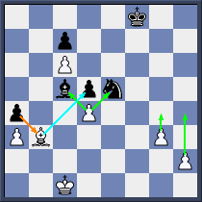

On the board shown on the left, the White’s h2 pawn can move to either h3 or h4 while the g3-pawn can only move one step. The d4-pawn can capture either Black’s Bishop or Knight while the c6 and a3-pawn are immobile. For Black, the a4-pawn can capture White’s Bishop on b3.

